|  |  |  |  |
| --- | --- | --- | --- |
|  | **Course Name: Introduction to Web Technology - Lab** | **Experiment No.1** | |
| **Course Code: 23CP306P**  **Faculty: Bhaumik Thakkar** | **Branch: CSE** | **Semester: V** |
| **Submitted by: Chetan Gadhiya**  **Roll no: 23BCP182** | | | |

**Objective :**

*To create a basic HTML web page demonstrating the use of headings, paragraphs, links, images, text formatting tags, and background styling.*

**Description :**

*This experiment introduces the structure of an HTML document using <!DOCTYPE html>, <html>, <head>, and <body>. It demonstrates various HTML elements such as headings (<h1>), paragraphs (<p>), bold/italic/underline, subscript (<sub>), superscript (<sup>), and links (<a>). It also includes inserting images (<img>) and setting a background image with CSS. This provides the foundation for understanding webpage design and content organization.*

**Program :**

<!DOCTYPE html>

<html>

<head>

    <title>Jay Swaminarayan</title>

</head>

    <body style="background-color: rgb(141, 165, 165);";

             background-size: cover;

             background-repeat: no-repeat;

             background-attachment: fixed;">

    <h1 style="color: white;">Jay Swaminarayan</h1>

    <h1>This is the Swaminarayan Bhagwan</h1>

    <p>Here is the <b>Live Katha</b> Link :</p>

    <a href="https://www.youtube.com/watch?v=Bk3-C0OqCxs&list=PLvP9u6s1SggDevcqjWAzuuwqUpv4WK1mb&index=4" target="_blank">Listen Dhun Kirtan</a>

    <br><br>

    <p>This is Very Important Link</p>

    <mark>It is being Controlled from New York</mark>

    <p>Chemical formula: H<sub>2</sub>O and Math: X<sup>2</sup></p>

    <p><del>Old info</del> <ins>New info</ins></p>

    <a href="https://www.swaminarayanbhagwan.org" target="_blank">Visit Swaminarayan Bhagwan</a><br><br>

    <img src="https://d1maxl27td41jk.cloudfront.net/files/Audio/SingerOrator/Pu.-Gyanjivandasji-Swami---Kundaldham-medium.jpg"

         alt="Pu. Gyanjivandasji Swami">

</body>

</html>

**Output :**

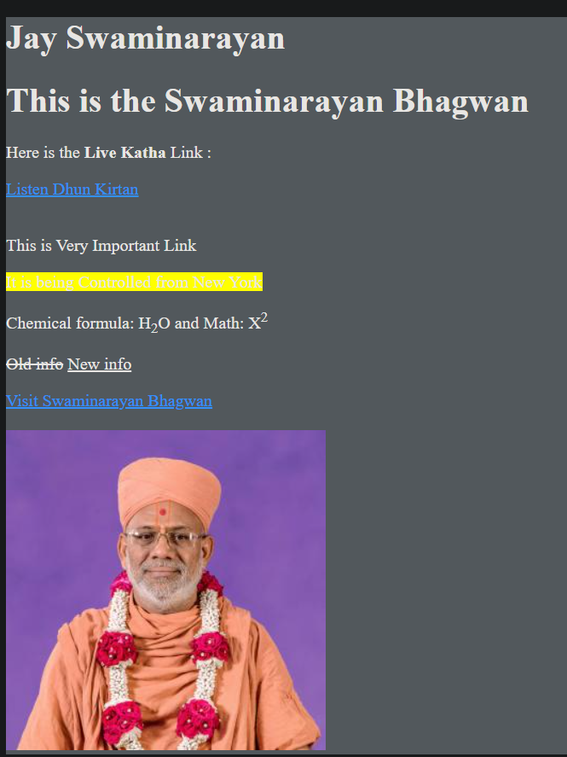

|  |  |  |  |
| --- | --- | --- | --- |
|  | **Course Name: Introduction to Web Technology - Lab** | **Experiment No.2** | |
| **Course Code: 23CP306P**  **Faculty: Bhaumik Thakkar** | **Branch: CSE** | **Semester: V** |
| **Submitted by: Chetan Gadhiya**  **Roll no: 23BCP182** | | | |

**Objective :**

*To design a responsive image gallery using HTML and CSS with navigation, grid layout, and basic styling.*

**Description :**

*This experiment demonstrates how to structure a webpage with header, nav, main, and footer sections. CSS properties are applied to style the background, navigation bar, and gallery layout. The gallery is created using the CSS Grid Layout (display: grid;) with the gap property. Each image is styled using borders, object-fit, and rounded corners. This experiment helps in understanding webpage layout, styling, and navigation.*

**Program :**

<!DOCTYPE html>

<html lang="en">

<head>

    <meta charset="UTF-8">

    <meta name="viewport" content="width=device-width, initial-scale=1.0">

    <title>Experiment 2 - Home</title>

    <style>

        * {

            margin: 0;

            padding: 0;

            box-sizing: border-box;

        }

        body {

            background: linear-gradient(135deg, #667eea 0%, #764ba2 100%);

            font-family: 'Segoe UI', Tahoma, Geneva, Verdana, sans-serif;

            line-height: 1.6;

            color: #333;

            min-height: 100vh;

        }

        header {

            background: linear-gradient(rgba(0,0,0,0.4), rgba(0,0,0,0.4)),

                        url('https://via.placeholder.com/1200x200/4a90e2/ffffff');

            background-size: cover;

            background-position: center;

            color: white;

            text-align: center;

            padding: 80px 20px;

            text-transform: uppercase;

            position: relative;

            overflow: hidden;

        }

        header::before {

            content: '';

            position: absolute;

            top: 0;

            left: 0;

            right: 0;

            bottom: 0;

            background: linear-gradient(45deg, rgba(74, 144, 226, 0.8), rgba(155, 89, 182, 0.8));

            z-index: -1;

        }

        header h1 {

            font-size: 3rem;

            margin-bottom: 10px;

            text-shadow: 2px 2px 4px rgba(0,0,0,0.5);

            animation: fadeInDown 1s ease-out;

        }

        header p {

            font-size: 1.2rem;

            animation: fadeInUp 1s ease-out 0.3s both;

        }

        @keyframes *fadeInDown* {

            from {

                opacity: 0;

                transform: translateY(-30px);

            }

            to {

                opacity: 1;

                transform: translateY(0);

            }

        }

        @keyframes *fadeInUp* {

            from {

                opacity: 0;

                transform: translateY(30px);

            }

            to {

                opacity: 1;

                transform: translateY(0);

            }

        }

        nav {

            background: rgba(255, 255, 255, 0.95);

            backdrop-filter: blur(10px);

            box-shadow: 0 2px 20px rgba(0,0,0,0.1);

            overflow: hidden;

            position: sticky;

            top: 0;

            z-index: 100;

        }

        nav a {

            float: left;

            display: block;

            color: #333;

            text-align: center;

            padding: 18px 25px;

            text-decoration: none;

            font-weight: 500;

            transition: all 0.3s ease;

            position: relative;

        }

        nav a:hover {

            background: linear-gradient(45deg, #667eea, #764ba2);

            color: white;

            transform: translateY(-2px);

        }

        nav a::after {

            content: '';

            position: absolute;

            bottom: 0;

            left: 50%;

            width: 0;

            height: 3px;

            background: linear-gradient(45deg, #667eea, #764ba2);

            transition: all 0.3s ease;

            transform: translateX(-50%);

        }

        nav a:hover::after {

            width: 80%;

        }

        main {

            padding: 40px 20px;

            max-width: 1200px;

            margin: 0 auto;

        }

        h2 {

            color: white;

            font-size: 2.5rem;

            margin-bottom: 20px;

            text-align: center;

            text-shadow: 2px 2px 4px rgba(0,0,0,0.3);

        }

        h3 {

            color: white;

            font-size: 1.8rem;

            margin: 30px 0 15px 0;

            text-shadow: 1px 1px 2px rgba(0,0,0,0.3);

        }

        p {

            color: white;

            font-size: 1.1rem;

            margin-bottom: 20px;

            text-shadow: 1px 1px 2px rgba(0,0,0,0.3);

        }

        table {

            width: 100%;

            border-collapse: collapse;

            margin: 30px 0;

            background: rgba(255, 255, 255, 0.95);

            border-radius: 15px;

            overflow: hidden;

            box-shadow: 0 10px 30px rgba(0,0,0,0.2);

        }

        th, td {

            padding: 15px;

            text-align: center;

            border: none;

        }

        th {

            background: linear-gradient(45deg, #667eea, #764ba2);

            color: white;

            font-weight: 600;

            text-transform: uppercase;

            letter-spacing: 1px;

        }

        tr:nth-child(even) {

            background: rgba(102, 126, 234, 0.1);

        }

        tr:hover {

            background: rgba(102, 126, 234, 0.2);

            transform: scale(1.02);

            transition: all 0.3s ease;

        }

        .highlight {

            color: #ffd700;

            font-weight: bold;

            font-style: italic;

            text-shadow: 2px 2px 4px rgba(0,0,0,0.5);

        }

        .box {

            width: 100%;

            max-width: 400px;

            padding: 25px;

            margin: 20px auto;

            background: rgba(255, 255, 255, 0.95);

            border: none;

            border-radius: 15px;

            box-shadow: 0 10px 30px rgba(0,0,0,0.2);

            text-indent: 30px;

            color: #333;

            font-size: 1.1rem;

            line-height: 1.6;

            transition: all 0.3s ease;

            position: relative;

            overflow: hidden;

        }

        .box::before {

            content: '';

            position: absolute;

            top: 0;

            left: 0;

            right: 0;

            height: 4px;

            background: linear-gradient(45deg, #667eea, #764ba2);

        }

        .box:hover {

            transform: translateY(-5px);

            box-shadow: 0 15px 40px rgba(0,0,0,0.3);

        }

        footer {

            background: linear-gradient(45deg, #2c3e50, #34495e);

            color: white;

            text-align: center;

            padding: 30px;

            margin-top: 40px;

            box-shadow: 0 -5px 20px rgba(0,0,0,0.2);

        }

        footer p {

            font-size: 1rem;

            text-shadow: none;

        }

*/* Responsive Design */*

        @media (max-width: 768px) {

            header h1 {

                font-size: 2rem;

            }

            nav a {

                padding: 15px 20px;

                font-size: 0.9rem;

            }

            main {

                padding: 20px 15px;

            }

            h2 {

                font-size: 2rem;

            }

        }

    </style>

</head>

<body>

    <header>

        <h1>Welcome to My Website</h1>

        <p class="highlight">Experiment 2: Using HTML & CSS</p>

    </header>

    <nav>

        <a href="Lab-2 index.html">Home</a>

        <a href="Lab-2 about.html">About</a>

        <a href="Lab-2 gallery.html">Gallery</a>

        <a href="#">Contact</a>

    </nav>

    <main>

        <h2>About This Page</h2>

        <p>

            This page demonstrates different <span class="highlight">CSS properties</span>

            such as <b>background-color</b>, <b>padding</b>, <b>border-collapse</b>,

            <b>font-size</b>, <b>font-family</b>, <b>text-indent</b> and more.

        </p>

        <div class="box">

            This is a sample text box. Notice the padding, border, and text indent properties applied here.

        </div>

        <h3>Sample Table</h3>

        <table>

            <tr>

                <th>Name</th>

                <th>Subject</th>

                <th>Marks</th>

            </tr>

            <tr>

                <td>Raj</td>

                <td>HTML</td>

                <td>90</td>

            </tr>

            <tr>

                <td>Anita</td>

                <td>CSS</td>

                <td>85</td>

            </tr>

        </table>

    </main>

    <footer>

        <p>&copy; 2025 My Website | Designed with HTML & CSS</p>

    </footer>

</body>

</html>

**Output :**

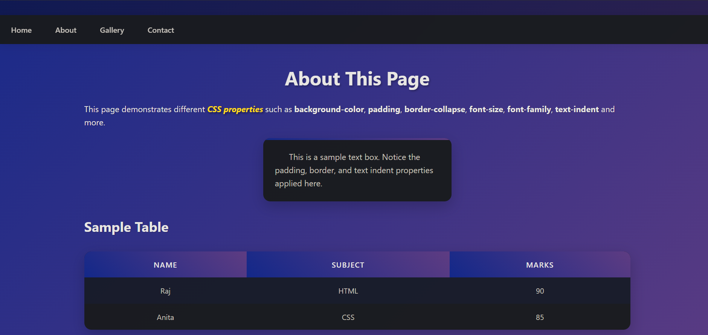

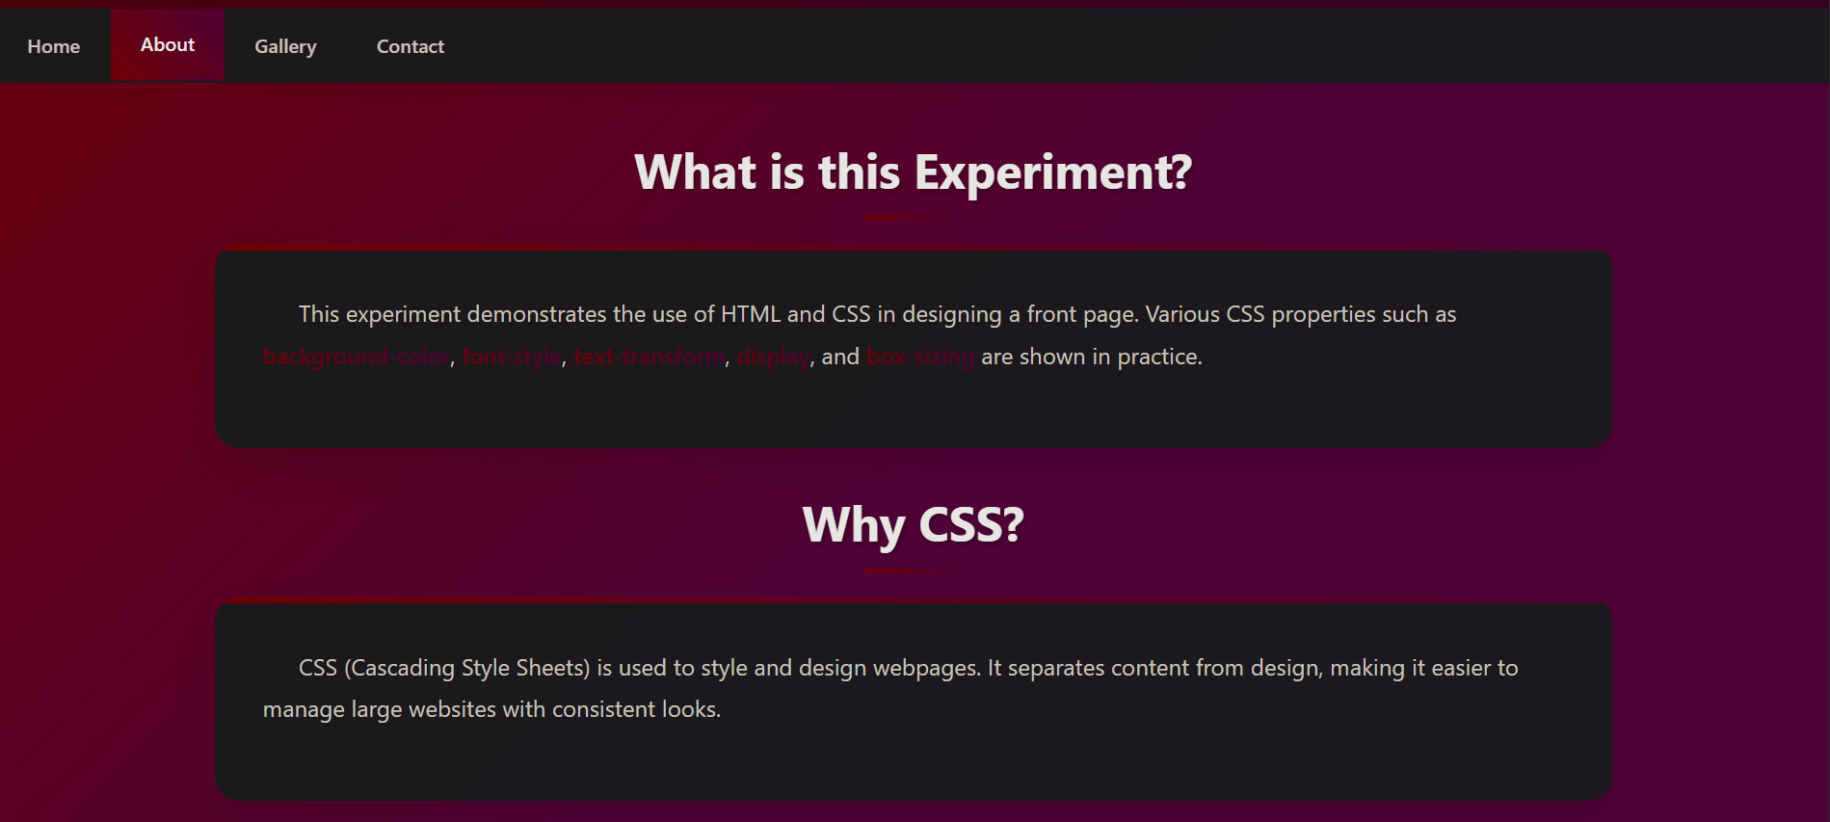

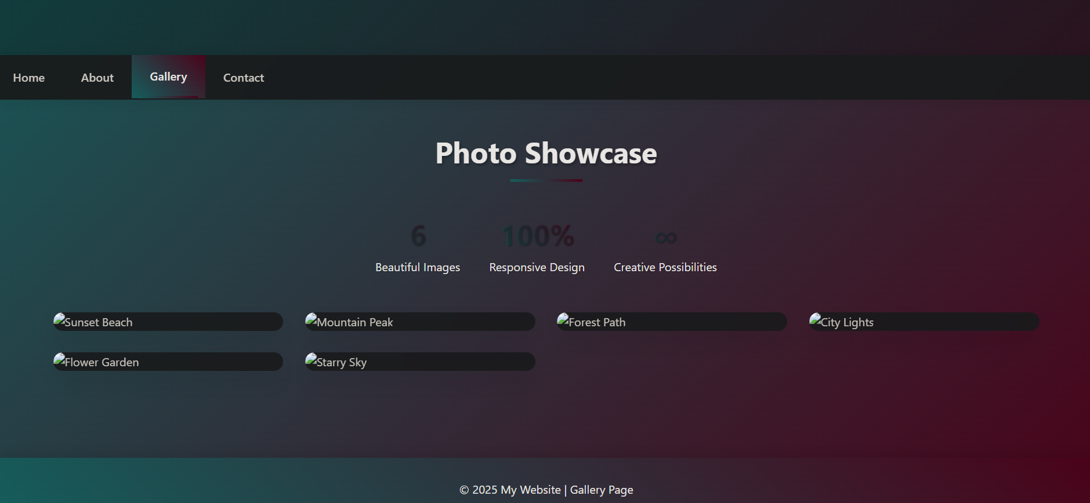

|  |  |  |  |
| --- | --- | --- | --- |
|  | **Course Name: Introduction to Web Technology - Lab** | **Experiment No.3** | |
| **Course Code: 23CP306P**  **Faculty: Bhaumik Thakkar** | **Branch: CSE** | **Semester: V** |
| **Submitted by: Chetan Gadhiya**  **Roll no: 23BCP182** | | | |

**Objective :**

*• To implement JavaScript variables, loops, event handling, and element selection.*

*• To create an interactive web form that collects user input and dynamically displays it in a table using JavaScript.*

**Description :**

*This experiment introduces* ***JavaScript fundamentals****:*

* *Variables (var, let, const)*
* *Loops (for, while, do-while, for-of, for-in)*
* *Event handling (addEventListener)*
* *DOM element selection methods (getElementById, querySelector, etc.)*

*It also demonstrates form handling in JavaScript. A form is created with input fields (name, age, gender). On submission, JavaScript captures the data and inserts it into a table dynamically. This experiment combines* ***HTML, CSS, and JavaScript*** *to build an interactive webpage.*

**Program :**

<!DOCTYPE html>

<html lang="en">

<head>

  <meta charset="UTF-8">

  <title>Lab 3 & 4 - JavaScript Basics + Form Handling</title>

  <style>

    body {

      font-family: "Segoe UI", Tahoma, Geneva, Verdana, sans-serif;

      margin: 0;

      padding: 0;

      background: linear-gradient(135deg, #74ebd5 0%, #ACB6E5 100%);

      min-height: 100vh;

    }

    header {

      background: #2c3e50;

      color: white;

      padding: 20px;

      text-align: center;

      box-shadow: 0 4px 8px rgba(0,0,0,0.2);

    }

    h1, h2 {

      margin: 10px 0;

    }

    .section {

      background: white;

      margin: 30px auto;

      width: 80%;

      max-width: 800px;

      padding: 20px;

      border-radius: 12px;

      box-shadow: 0 4px 12px rgba(0,0,0,0.15);

    }

    button, input[type="submit"] {

      background: #3498db;

      color: white;

      border: none;

      padding: 10px 18px;

      border-radius: 6px;

      cursor: pointer;

      font-size: 14px;

      transition: 0.3s;

    }

    button:hover, input[type="submit"]:hover {

      background: #2980b9;

    }

    form {

      display: flex;

      flex-wrap: wrap;

      gap: 10px;

      align-items: center;

      justify-content: center;

    }

    form label {

      font-weight: bold;

    }

    form input[type="text"], form input[type="number"] {

      padding: 6px;

      border: 1px solid #ccc;

      border-radius: 6px;

    }

    #output {

      margin-top: 15px;

      font-weight: bold;

      color: green;

      text-align: center;

    }

    #data-table {

      border-collapse: collapse;

      width: 70%;

      margin: 20px auto;

      box-shadow: 0 4px 10px rgba(0,0,0,0.1);

      border-radius: 8px;

      overflow: hidden;

    }

    #data-table th {

      background: #34495e;

      color: white;

      padding: 10px;

      text-transform: uppercase;

      font-size: 14px;

    }

    #data-table td {

      border: 1px solid #ddd;

      padding: 10px;

      text-align: center;

    }

    #data-table tr:nth-child(even) {

      background: #f9f9f9;

    }

    #data-table tr:hover {

      background: #f1f1f1;

    }

  </style>

</head>

<body>

  <header>

    <h1>Lab 3 & Lab 4 - JavaScript Practical</h1>

  </header>

*<!-- ================= LAB 3 ================= -->*

  <div class="section">

    <h2>Lab 3: JavaScript Basics</h2>

    <p>Check the console (<kbd>F12 → Console</kbd>) for variable & loop output.</p>

    <div style="text-align:center;">

      <button id="clickBtn">Click Me (Event Handling)</button>

      <p id="output"></p>

    </div>

  </div>

*<!-- ================= LAB 4 ================= -->*

  <div class="section">

    <h2>Lab 4: Form Data → Table</h2>

    <form id="myform">

      <label for="fname">Name</label>

      <input type="text" id="fname" name="fname" required>

      <label for="age">Age</label>

      <input type="number" id="age" name="age" required>

      <label><input type="radio" name="gender" value="Male" required> Male</label>

      <label><input type="radio" name="gender" value="Female"> Female</label>

      <input type="submit" value="Submit">

    </form>

    <table id="data-table"></table>

  </div>

  <script>

*/* ========== LAB 3 SCRIPT ========== */*

*// Variables*

    var a = 10;

    let b = 20;

    const PI = 3.14;

    console.log("Var a:", a, "Let b:", b, "Const PI:", PI);

*// Loops*

    console.log("For loop:");

    for (let i = 0; i < 3; i++) {

      console.log("i =", i);

    }

    console.log("While loop:");

    let x = 0;

    while (x < 3) {

      console.log("x =", x);

      x++;

    }

    console.log("Do-While loop:");

    let y = 0;

    do {

      console.log("y =", y);

      y++;

    } while (y < 3);

    console.log("For-of loop:");

    const arr = [10, 20, 30];

    for (const value of arr) {

      console.log(value);

    }

    console.log("For-in loop:");

    const obj = { name: "John", age: 22 };

    for (const key in obj) {

      console.log(key, "=", obj[key]);

    }

*// Event handling*

    const btn = document.getElementById("clickBtn");

    const output = document.getElementById("output");

    btn.addEventListener("click", function() {

      output.innerText = "Button was clicked!";

    });

*// Selection of Elements*

    console.log("getElementById:", document.getElementById("clickBtn").innerText);

    console.log("querySelector:", document.querySelector("#clickBtn").innerText);

*/* ========== LAB 4 SCRIPT ========== */*

    const form = document.getElementById("myform");

    function **getGender**() {

      const radios = document.getElementsByName('gender');

      for (let radio of radios) {

        if (radio.checked) {

          return radio.value;

        }

      }

    }

    function **addDataToTable**(*name*, *age*, *gender*) {

      const table = document.getElementById('data-table');

      if (table.rows.length === 0) {

        const header = table.insertRow();

        header.insertCell(0).outerHTML = "<th>Name</th>";

        header.insertCell(1).outerHTML = "<th>Age</th>";

        header.insertCell(2).outerHTML = "<th>Gender</th>";

      }

      const row = table.insertRow();

      row.insertCell(0).innerText = *name*;

      row.insertCell(1).innerText = *age*;

      row.insertCell(2).innerText = *gender*;

    }

    form.addEventListener("submit", function(*event*) {

*event*.preventDefault();

      const formdata = new FormData(form);

      const name = formdata.get("fname");

      const age = formdata.get("age");

      const gender = getGender();

      addDataToTable(name, age, gender);

      form.reset();

    });

  </script>

</body>

</html>

**Output :**

